**Kol simcha torah gazette**

**For parshas yisro 5784**

Volume 8 Issue 21 (Whole #379) 24 Shevet 5784/ Febuary 3, 2023

**Printed L’illuy nishmas Nechama bas R’ Noach, a”h**

For a free subscription, please forward your request to [***keren18@juno.com***](mailto:keren18@juno.com)

***Past emails can be found on the website ShabbosStories.com under Brooklyn Torah Gazette***

**Tribute To Rav Matisyahu Salomon On His Shloshim**

**By** [**Rabbi Raphael Fuchs**](https://www.jewishpress.com/author/rabbi-raphael-fuchs/)

**[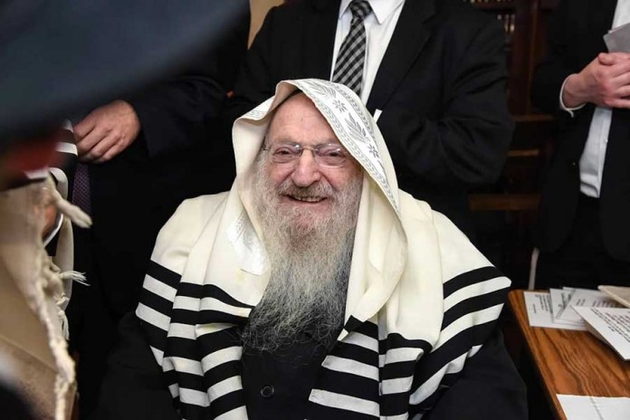](https://www.jewishpress.com/wp-content/uploads/2024/01/Fuchs-012624.jpg)**

**Rav Salomon at the bris of the author's sister's son.**

The Jewish people have been blessed with many remarkable leaders throughout history, and Rabbi Matisyahu Salomon, zt”l, is certainly one of them. His influence extended far beyond the walls of the Beis Medrash Govoha (BMG) in Lakewood N.J., where he served as mashgiach for the past quarter century, touching the lives of many with his teachings and exemplary way of life. Rav Matisyahu devoted his life to bettering the lives of others and inspired tens of thousands to strengthen themselves in limud haTorah and avodas Hashem.

**Early Life and Education**

Rav Matisyahu Salomon was born in London in 1936 to Reb Yaakov and Mrs. Ettil Salomon. From an early age, his passion for Torah study and dedication to Jewish values were evident. He joined the Gateshead Yeshiva, where he became exceptionally close to his chavrusa, Rav Chaim Kaufman, who later founded the Gateshead Yeshiva L’Tzeirim.

In 1960, he married Miriam Falk, sister of Rav Eliyahu Falk, zt”l. Rav Matisyahu was a talmid of Rav Elya Lopian, zt”l, in Yeshiva Kfar Chassidim, where he developed his sterling and refined character. Rav Matisyahu considered Rav Lopian to be his rebbe muvhak. Rav Matisyahu always believed he would be a rosh yeshiva, but Hashem had other plans for him. At the levaya, one of his sons-in-law remarked that one of the keys to the massive success that Rav Matisyahu had was that for most of his life he did something that he did not want to do. Rather, he acted out of his selfless devotion to others.

**Leadership and Guidance**

In the late 1960s, Rav Matisyahu began serving as an assistant mashgiach under Rav Moshe Schwab, zt”l, and later took over as mashgiach of Gateshead Yeshiva. His prowess in Torah learning was so impressive that his appointment as “only” the mashgiach of the Gateshead Yeshiva came as a surprise to those who knew him best. Rav Matisyahu served as mashgiach in Gateshead for about 30 years, until moving to Lakewood in 1997 to assume the role of mashgiach of BMG. Rav Matisyahu’s impact has been felt across continents and generations.

**Commitment to Excellence**

Rav Matisyahu is best known in American circles for his quarter-century tenure as the mashgiach of Bais Medrash Govoha. As previously mentioned, Rav Matisyahu’s devotion to helping others grow in avodas Hashem began much earlier at the yeshiva of Gateshead, where he spent three decades impressing upon thousands a lifelong commitment to excellence.

In 1998, Rav Matisyahu succeeded Rav Nosson Wachtfogel, zt”l, as mashgiach ruchani of the largest and most prestigious yeshiva in the United States. The Salomons agreed to move to a foreign country for the sole purpose of bettering other people’s lives.

During the subsequent years, Rav Matisyahu brought unprecedented enthusiasm to the Lakewood yeshiva. Rav Matisyahu’s weekly schmuessen at BMG drew over a thousand in attendance. With his warm personality and his commitment to refining the character of bnei Torah, the mashgiach’s reputation spread. His influence extended beyond his duties as the yeshiva’s mashgiach as he was transformed into a hashkafic mentor of both religious and non-religious frum Jews across the globe.

**Legacy and Impact**

In a world characterized by rapid change, Rav Matisyahu Salomon remains a steadfast beacon of tradition, guiding with wisdom, love and an unwavering commitment to the values that have sustained us throughout history. A significant component of Rav Matisyahu’s legacy is his role in raising awareness of the dangers of technology. Rav Matisyahu was a frontrunner in this battle long before many realized the extent of the threat it poses.

Rav Elya Brudny of the Mirrer Yeshiva in Brooklyn remarked at the levaya that Rav Matisyahu was fighting the “sin of the generation.” Nearly 12 years ago, Rav Matisyahu organized a massive gathering in Citi Field stadium to raise awareness of the dangers of technology. The event drew over fifty thousand people, filling Citi Field and including thousands of others at a nearby stadium with a live hookup.

**The Fate of His Personal Well-Being was Not a Factor**

Ahead of the gathering, a gadol in Eretz Yisrael warned Rav Matisyahu that by doing this he was starting up with the S”A (evil angel), which could take “revenge” on him in various ways. Undeterred, the mashgiach continued with the gathering; the fate of his personal well-being was not a factor when it came to the needs of klal Yisrael, and in technology, he recognized a danger of historic proportions that had to be addressed. Due to Rav Matisyahu’s efforts, thousands of people do not have smartphones today and many others have put filters on their devices.

After suffering from a years-long illness, two weeks ago this great leader was taken from us at the age of 86. Rebbetzin Salomon passed away in 2016. Rav Matisyahu Salomon is survived by his wonderful family of children and grandchildren.

May his memory be a blessing.

*Reprinted from the January 26, 2023 website of The Jewish Press.*

**Rav Avigdor Miller on**

**Should One Rejoice at**

**The Downfall of the Wicked**

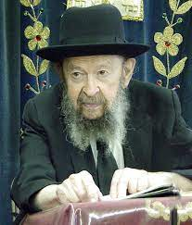

|  |
| --- |
| Aside from singing about good things, should somebody sing at the downfall of *resha'im (wicked people)*, even though those *resha'im* were not pursuing him or endangering him?  And the answer is absolutely. It says that Dovid invented the word "*Hallukah*" that's Dovid's invention, praise *Hashem*. Now that word appears in the *Tehillim* many times, but the first time he said it was when he saw the downfall of the *resha'im*. "*Yitamu chato'im min ha'aretz, u'resha'im od einam borchi nafshi es Hashem, hallukah*." So, the first expression of gratitude to *Hashem* was when he saw the downfall of the wicked. He looked forward and saw how the wicked will be destroyed.  Now that is exemplified by "*Oz yoshir Moshe u'vnei Yisrael*", they sang. They sang when they saw the Egyptians being drowned. Now the *malachim (the heavenly angels)* were not allowed to sing. *Hashem* said, "Don't sing." He said to the *malachim*, "because that's My handiwork, *maaseh yadai*, I made the Egyptians, now they are being drowned, don't sing."  So, the question arises, if you shouldn't sing at the destruction of human beings that *Hashem* made, so why did *Moshe u'vnei Yisrael* sing?  The answer is *Moshe uv'nei Yisrael* sang for a reason, because when you sing at the downfall of the *resha'im*, you become better. You recognize *Hashem's* handiwork, you get more *emunah*. But *malachim* don't need any *emunah*, the *malachim* can't get any better, so *malachim* are told not to sing. But we are supposed to sing, because we get better when we sing at the downfall of the *resha'im*.  And so, when you read in Manhattan, they are dying one after the other, 42, 39, 38 are dying in Manhattan of AIDS, you should be very happy. "*Hinasei* *Shofet ha'aretz*" be elevated, O judge of the world.  How are You elevated? "*Hosheiv gmul al gei'im*" “when You turn back recompense on the arrogant, those *resha'im* who ridicule us. I walked into a store on King's Highway, and in the store was a man behind the counter with an earring. I was wearing a beard. So, he's ridiculing me. He looked down at me with scorn, with *bizayon*. I was a customer. Still, I didn't have an earring in my ear. [laughter] His older sister said, "Please! Lou, stop it!" she said to him. The store closed down soon after that, *baruch Hashem*. So, we're happy the store closed down, and we know what's going to happen to this boy. He'll go *b'derech kol ha'aretz*, and someday, if he's important, he'll be in the New York Times, that he passed away at the age of 32.  I told you the story about Mel Rosen, didn't I? Mel Rosen, he was the president of the gay synagogue in Manhattan. And he was active in Lambda, National Gay Task Force, other things like that, *mitzvos* and *ma'asim tovim* all over the place. [laughter] One day, he saw in the Jewish Week a certain notice somebody put up that Rabbi Miller said that AIDS is a punishment of retribution from *Hashem*. So, he put in a notice this (the first notice) cost money, somebody put this in. But they printed from him, and they joined it, free of charge. Of course, that's what they always do. And they said "Miller is ignorant, Miller is ignorant he said. AIDS is caused by a germ" [laughter], you hear that *chochom*?! And not long afterwards, I see his picture in the New York Times on the obituary page. And now he's in *Gehinnom*, and now he understands what causes AIDS.  And so, if you could have changed him while he was still alive, certainly, *Yitamu chatoim, vloi chotim*, if you can make the sin stop and not the sinners, you should do it. But suppose he is arrogant and he thinks he knows everything, and he refuses to listen, and the time comes when the *yad Hashem* strikes him down, we should see in it, *Oz yoshir*", we should sing the song of *Hashem*, that *HaKadosh Baruch Hu* is doing things to teach us that He's around. Not like they try to make *Hashem* pushed out of the world entirely. The atheists want us to forget about *HaKadosh Baruch Hu*, and *Hashem* says, "No, you don't. Can't forget about Me."  So therefore, certainly we should sing at the downfall of *resha'im*. |

*Reprinted from a recent email of Toras Avigdor featuring A Moment with Rabbi Avigdor Miller adapted from Tape #903 (January 1993)*

**The Five Voices that the**

**Jews Heard at Mt. Sinai**

**From the Teachings of the Lubavitcher Rebbe**

**Rabbi Menachem Mendel Schneerson, Zt”l**

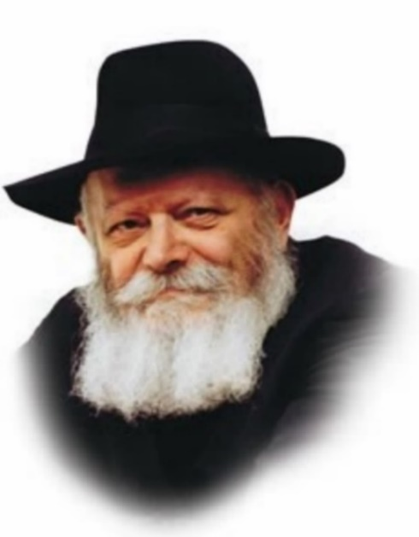

The events surrounding the Giving of the Torah at Mount Sinai are described in this week's portion, Yitro: "There were voices [thunder] and lightening...and the voice of a shofar...and the voice of the shofar...and G-d answered him by a voice." The Talmud comments: "The Torah was given in five voices." (The word "voices" appears once, and "voice" three times. Added together, they equal five.)

Every word in the Torah is significant and exact, especially in its narration of the Giving of the Torah, the single most important event in history. The Giving of the Torah is synonymous with G-d's revelation in the world; if the Torah tells us that it was accomplished in "five voices," it is obvious that this expresses something theologically essential.

**The Five Different Type or**

**Levels of Divine Revelation**

The function of any "voice" is to reveal something that was previously concealed; a person utilizes his voice to express the ideas that were hidden in his mind and heart. It follows, then, that the "five voices" alluded to at the Giving of the Torah refer to five different types or levels of Divine revelation.

In general, the world is represented by the number four. The world was created through the four-letter, ineffable Name of G-d. The higher, spiritual worlds are divided into four realms: Atzilut, Briya, Yetzira and Asiya. Even the creations on the physical plane are divided into four groups: inanimate, vegetative, animal and human.

These four distinctions encompass everything in our world: The level of inanimate is the lowest, without any (visible) vitality whatsoever. Above this is the vegetative, with limited vitality. The next level upward belongs to animals, and the highest, of course, is man, who possesses the intellectual capacity to grasp profound spiritual truths. By means of his intellect, he can even grasp that there are some things that are higher than the limitations of creation.

**A Level of Holiness that Transcends the World**

If the Torah had been given "in four voices," it would suggest that G-d revealed Himself at Mount Sinai only as much as He relates to the framework of the natural world. However, by telling us that the Torah was given "in five voices," the implication is that G-d revealed a level of holiness that completely transcends creation's boundaries.

The number five thus represents the perfection of the natural order (the number four), with the addition of one: G-d Himself. At Mount Sinai, the very highest levels of holiness were revealed. And ever since then, whenever a Jew studies Torah, he merits to access not only the levels of holiness that pertain to the world, but even those that transcend it.

*Reprinted from the Parshat Yitro 5761/2001 edition of L’Chaim Weekly. Adapted from Likutei Sichot, vol 6*

**Rabbi Berel Wein on**

**Parshat Yitro 5784**

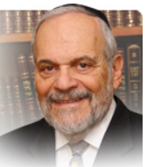

There are two different viewpoints as to the timing and to the nature of the visit of Yitro to the Jewish encampment in the desert of Sinai. One opinion is that he came before the revelation of G-d to the Jews and the granting of the Torah to them. The other opinion is that he came after Sinai and the Torah revelation. I think that these two different opinions really delve into the character and nature of Yitro himself, as much as they deal with chronological events recorded for us in the Torah.

Rashi indicates that Yitro came because of his awareness of the miracle of the splitting of Yam Suf and of the subsequent battle between Amalek and Israel. If so, as Rashi seems to indicate by not mentioning the Torah revelation as one of the causes for his leaving his country, his position and his faith to come to join Israel in its journey, then it seems that Yitro’s “conversion” to Judaism was motivated by seemingly outside influences rather than by personal soul-searching.

If, however Yitro arrives at the camp of Israel after the revelation at Sinai, then one can justifiably argue that it was an inner recognition of the veracity of the newly revealed Torah. Recognition of the truths of its monotheistic moral code that Sinai represents would have motivated his abandonment of past idols and ideals and drove him to his new attachment to the G-d and people of Israel.

In this seemingly pedantic discussion on the timeline of events that befell the Jewish people in their forty-year sojourn in the desert of Sinai, lies a very deep and relevant understanding of the Jewish world and its obstacle laden path to faith and belief.

Throughout Jewish history there have been many who were influenced by outside, historical events that made them wonder in amazement at the survival and influential presence of the Jewish people. The Jew was always outnumbered and discriminated against by world society. It has always been felt by many that it was only a matter of time that Judaism and Jews would finally cease to exist. Yet from the ancient pharaohs to the modern age the survival of the Jewish people has remained a troublesome mystery to world society.

The world is aware of the miracles that have accompanied us while crossing the sea of history and of the constant battle that we have been forced to fight against Amalek. This awareness has provided us with a few allies from the outside world to aid us in our quest for equality and fair treatment. These people are valuable friends and allies but are rarely if ever true converts to Judaism. However, we have been blessed in every generation by the attachment of people to Judaism and Israel because of the appreciation and recognition of the G-d-given moral code that the Torah represents.

It is the inner spiritual drive of their souls that drove and drives these people to become converts to Judaism. Since it is difficult, if not wellnigh impossible, for any Jewish rabbinic court to explore the inner soul of any other human being, the problems of formal conversion to Judaism, especially in our time, are many and difficult. Yet, Yitro stands as an example as to the benefits to the individual and the nation as a whole of those who are not born Jewish and who stubbornly wish to attach themselves to the people and destiny of Israel.

Shabbat shalom

*Reprinted from the current website of rabbiwein.com*

**Carrying a Gun or a**

**Doctor’s Phone on Shabbos?**

**By Rabbi Hillel Raskin**

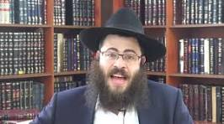

**Rabbi Hillel Raskin**

Can I carry a gun in a holster on Shabbos in a locale that does not have an eruv? On Shabbos, one is permitted to go outside wearing a garment (malbush) or ornament (tachshit). Wearing something outside that doesn’t fall under those two categories is a Shabbos violation.

The Mishna records a debate about whether weapons are considered ornaments for a soldier. Rabbi Eliezer holds they are, but the chachamim disagree since they’ll be abolished when Moshiach comes. If they were truly adornments, they would be worn even when there is no longer any need for them.

Halacha follows the chachamim, and if one wears them in the normal fashion — e.g., in a holster — one is liable min hatorah. For a soldier on active duty, some poskim posit that his weapons fall under the category of a malbush as they are part of his attire or are considered a tachshit for him. Of course, in a situation of active pikuach nefesh, carrying for safety purposes is absolutely permitted.

What about carrying a communication device outside? R. Shlomo Zalman Auerbach was reluctant to allow doctors to carry phones in a bona fide reshus harabim, arguing that a doctor on call in such an area is required to stay at home and not go to shul.

When heading to a patient in danger, he may carry his phone outside — with a shinui if possible (e.g., in his hat or socks) — or as an integral part of a “Shabbos belt.” If the area is a karmelis, the doctor may carry the phone with a shinui whenever he is on call.

In cases that warrant this, some suggest wearing a smart watch with its own calling capabilities, which serves more clearly as a tachshit. To minimize its chillul Shabbos, any settings that aren’t needed should be turned off before Shabbos.

For the two-way radios (“walkie-talkies”) worn by Hatzalah members on call, R. Moshe Feinstein ruled in 5739 that they may wear it on Shabbos since it gives them a sense of respect and is considered a “tachshit” for them. Additionally, if Hatzalah members were forced to stay near their devices (i.e., at home), there is concern that fewer volunteers would agree to be on call for Shabbos.

Reprinted from the Parshat Va’yeira 5784 edition of The Weekly Farbrengen. Rabbi Raskin is Rov of Anash in Petach Tikva, Israel.

**Thoughts that Count**

*And Yitro rejoiced for all the goodness that the L-rd had done to Israel, that He delivered him out the hand of the Egyptians* (Ex. 18:9)

What is meant by "that he delivered him from the hand of the Egyptians"? Shouldn't the Torah have used the word "them," meaning the Jewish people, rather than "him"? Yitro had served as one of Pharaoh's chief advisors, and now realized that he should have perished along with the rest of the Egyptians. Thus, he was grateful to G-d for not only saving him physically, but for giving him the idea to convert to Judaism. *(Be'er Mayim Chaim)*

*Then you shall be My own treasure (segula) from among all the peoples* (Ex. 19:5)

The Hebrew word "segula" means a characteristic or trait, i.e., something that does not depend on logic but is simply a "given" of nature. Similarly, G-d's love for the Jewish people has no rational basis, and exists solely because such was His will to choose them. *(Kadmonim)*

*Reprinted from the Parshat Yitro 5761/2001 edition of L’Chaim Weekly.*

**From the Nazi Death Camps to Chief Rabbi of Israel**

**By Daniel Keren**

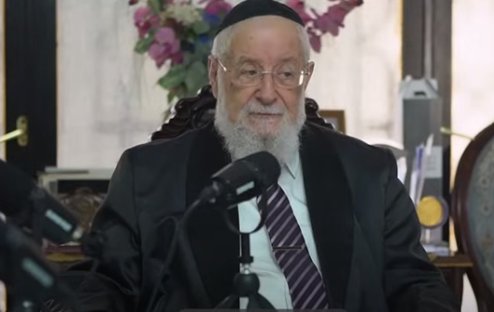

A recent Living L’Chaim – Inspiration for the Nation podcast hosted by Yaakov Langer was recently taped in Israel where he interviewed the former Ashkenazi Chief Rabbi of Israel – Rabbi Yisroel Meir Lau in the aftermath of the October 7th Simchas Torah massacre by Hamas terrorists (yemach shemam) of Israelis in the south of Israel.

One of the interesting anecdotes that Rabbi Lau revealed to Yaakov Langer was the fact that he was descended from a long line of rabbis on his father’s side going back hundreds of years. When his father Rabbi Moshe Chaim Lau, hy”d, realized that he was not going to survive the Nazi onslaught of Polish Jewry, he begged his older son Naftali to keep an eye out for his younger brother Yisroel.

The father explained that he understood that Naftali was not going to carry on the family tradition of being a rabbi because of the disruption that the Second World War had made in his life. But his younger brother could still continue the Lau heritage.

Naftali who would later become the Israeli Consul-General in New York City, risked his life to protect his younger brother and make sure that he after the liberation of the Buchenwald Concentration Camp would come to Israel where under the guidance of his uncle and later a student of his martyred father, Yisroel Meir Lau indeed became a rabbi.

And not only did young Yisroel Meir Lau gain simcha, but he became the sixth Ashkenazi Chief Rabbi of the Holy Land and today his son Rabbi David Lau is the current Chief Ashkenazi Rabbi of Israel.

To view this 50-minute podcast, google either “My Impossible Journey from Death Camps to Chief Rabbi of Israel” or <https://youtu.be/2gVaohg6yJ0?si=gc7H5L-dapYv1rvL>

*Reprinted from the January 26, 2023 edition of The Jewish Connection.*

**More Torah Thoughts**

**for Our Parsha**

*When the ram's horn sounds long, they shall come up to the mountain* (Ex. 19:13)

When the Torah was given, all vestiges of idolatry had to be removed from the Jewish people, including the idea that any creation can have its own inherent holiness; only G-d can impart sanctity. Thus, in order to make sure that no one thought that the reason the Torah was given on Mount Sinai was that the mountain itself was holy, G-d commanded that immediately afterward it revert to being a "regular" mountain, with animals grazing on it, etc. The "sanctity" of Mount Sinai lasted only as long as the Divine Presence rested upon it. *(Meshech Chochma)*

*Reprinted from the Parshat Yitro 5761/2001 edition of L’Chaim Weekly.*